Gold Price Linear Model

College of Staten Island City University of New York

Weicong Feng

Professor: Dr. Bryan S. Weber

November 2019

# Intro

# Gold is not a general precious metal but also potential currency, important industrial raw material, adornment, and financial tools. Whether for investors or financial policymakers, or related industrial producers, forecasting gold prices has important practical implications. People have been keen to predict gold prices, just like forecasting stock market fluctuation. This paper creates a model to explain the relationship between the gold price and the relevant variables.

# This paper uses the monthly data from 1970 to 2019 to estimate a linear regression model in order to explain different factors' impact on the gold price change. This research not only verifies that the gold price is significantly affected by the US dollar price, interest rates, inflation, and equity market but also gives a model with specific predictive power.

# Literature Review

# In reality, the economy is complex, and gold prices are affected by a number of factors. Kauffmann and Winters (1989) pointed out that the US dollar index has a major impact on the gold price, while Barsky and Summers (1988) claimed that interest rate correlated with gold price in the long term, is a dominant factor. Other researches indicated monetary policy, inflation, demand and supply for gold, and politics even have different impacts on the gold price.

# US Dollar Index: Kauffmann and Winters (1989) believed the price of gold fluctuates inversely with the value of the US dollar mainly because its price is denominated in the US dollar (Said Elfakhani el., 2009). However, Soumya Sharma (2015) interpreted this relationship as the appreciation of the US dollar causes gold, which is denominated in the US dollar to appreciate against other currencies, thereby suppress the consumption of gold (Soumya Sharma, 2015).

# Interest Rates: In general, interest rates are considered to be inversely related to the gold price. Actually, the real rate is more important than nominal rates. High-interest rates drive investors to hold higher yields on risky assets because holding non-interest precious metals means higher holding cost. During negative real interest rates periods, holding bonds leads to lose purchasing power, while gold is a traditional tool for a store of wealth (Soumya Sharma, 2015).

# Stock Market: Many experts believe the stock market, oil, and silver volatility have a great impact on the gold price, and Aylin Erdogdu (2017) and Korhan Gokmenoglu (2015) agree with this theory. In general, financial academics think gold is a hedge asset whose demand will increase in economic crisis, so it should be a contrary indicator of the stock market. As for its relationship with other precious metals, it is not a causal relationship, but rather they are all affected by similar factors and cause the same-direction relationship.

# The data used in the previous researches is basically a span of fewer than 20 years. For instance, Aylin Erdoğdu used data from 2003 to 2016, and Katarzyna Mamcarz used data from 2000 to 2013. Nevertheless, gold experienced an unprecedented bull market from 2000 to 2012, the market overshot on the upside. It is easy to lead to overfitting when the used data span too short to span the cycles. This study uses monthly data from 2070 to 2019, and this problem will be overcome. Some of the preceded studies used GARCH (generalized autoregressive conditionally heteroscedastic) or multiple linear regression more advance model to fit data better, while this paper uses a relatively simple linear regression model.

# Data

In general, the gold price is mainly driven by the following factors:

* Currency markets
* Interest rate/monetary policy
* Inflation
* Geopolitics
* Equity markets
* Demand

The currency market is an essential factor for the gold price, especial in the US dollar price, because the gold price is usually denominated in US dollars. The federal interest rate and 10 years yield could be used to measure short-term interest rates and long-term interest rates. CPI is a pretty good indicator of inflation. During the attempt of involving geopolitics, it was found that wars and conflicts happened almost every year, some wars even continued from 15 years ago. Simple dummy variables cannot explain the impact of geopolitics on the gold price. Hence, the geopolitics factor is ignored. In the first year or two years of the crisis, especially the big economic crisis, the stock market will have a clear opposite direction with the gold price. After that, the stock began to recover, and gold is still a risk-hedging tool that investors hold in large numbers, and they are starting to run in the same direction. Therefore, the direction of stock volatility and gold price are not clear. On the other hand, Historical supply and demand data of gold only found the last 10 years and had to give up.

US dollar index, federal interest rate, 10 years yield, and S&P500 historical data were download from finance yahoo, while gold price historical data was download from GOLDHUB (www.gold.org) for the period of December 31, 1970, to May 31, 2019. Meanwhile, the CPI historical data was download from the datahub. Theoretical, the gold price can be predicted based on the percentage change of the US dollar index, federal interest rate, 10 years yield, and CPI, S&P500 return. There is a total of 582 observations. 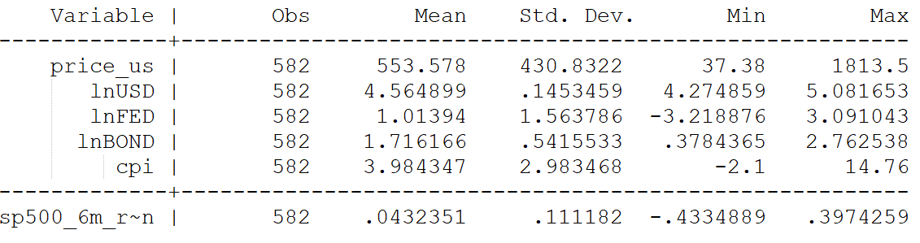

Figure 1

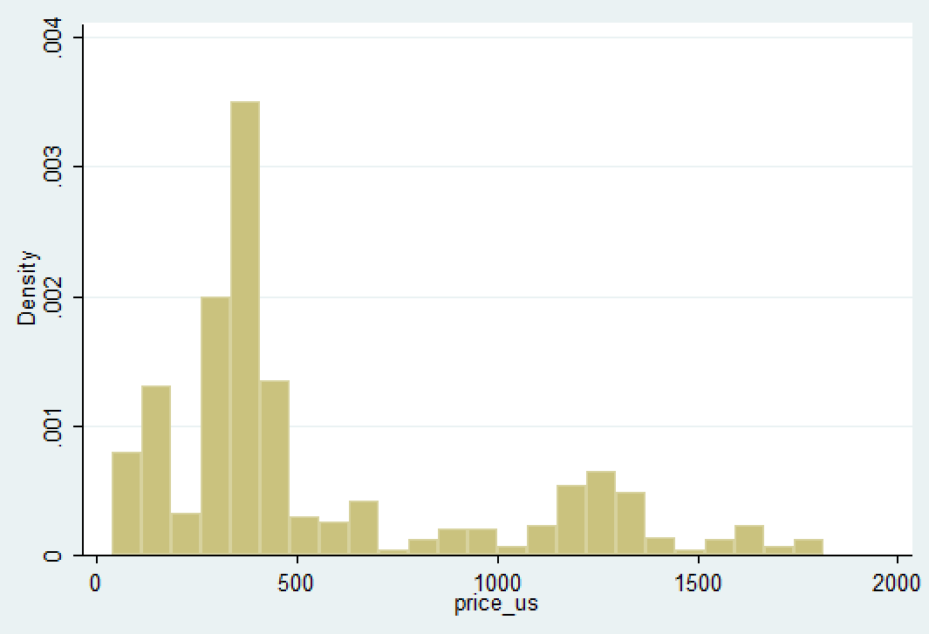

Figure 2

From the above histogram, it points out that a large number of observations are concentrated between 300-450 US dollars, following by between 1100-1400 US dollars. This is because gold has been trading in these two price ranges for a long time.

US Dollar Index is a factor that has a great impact on the gold price. Because gold is generally denominated in US dollars, so the gold price is inversely related to the US dollar, as shown in Figure 3 below. In this sample, the LOG of the US Dollar Index runs around 4.5648 and has a lower variance. On the other hand, the gold price is very sensitive to interest rates. When the economy is in recession, interest rates and most of the investment returns are declining and unattractive, and investors will buy more gold as an anti-risk asset. Federal fund rate and 10 years bond yield rate can be considered as short-term and long-term interest rate indicators, respectively.

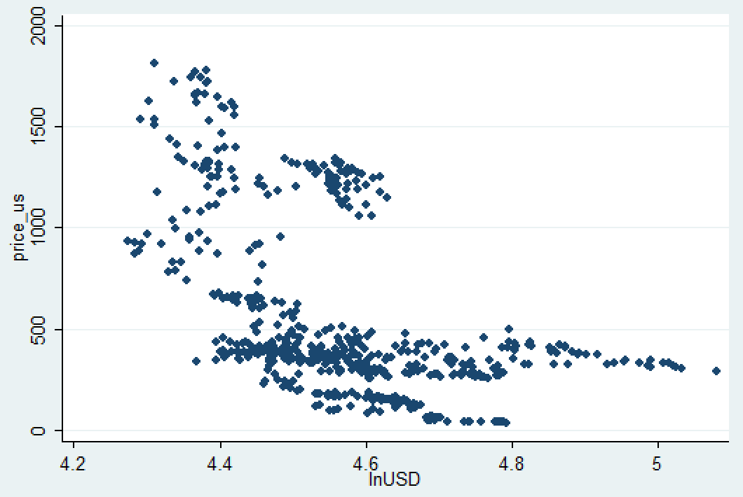

Figure 3

As theory, figure 4 and figure 5 show that the federal fund rate and 10 years bond yield are in an inverse relationship with the gold price.

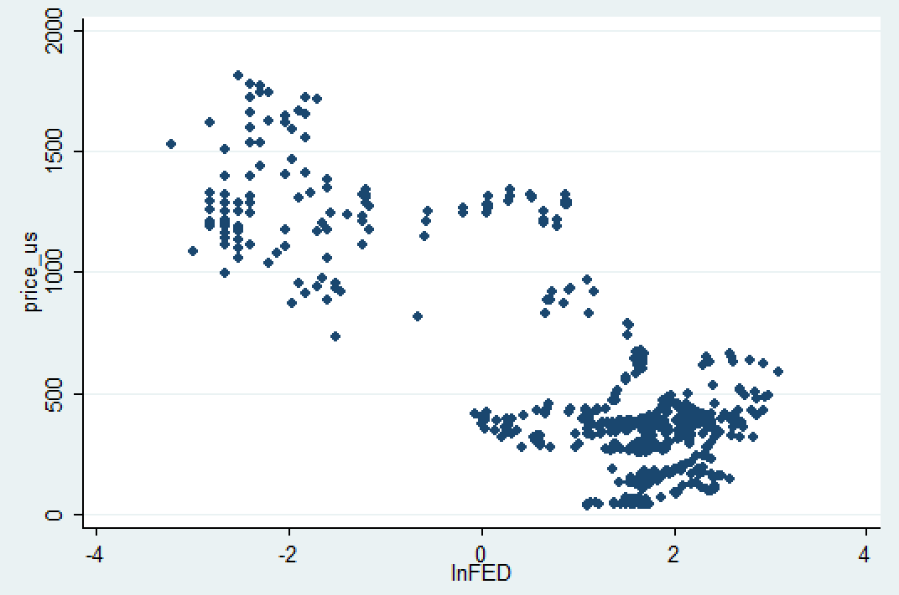

Figure 4

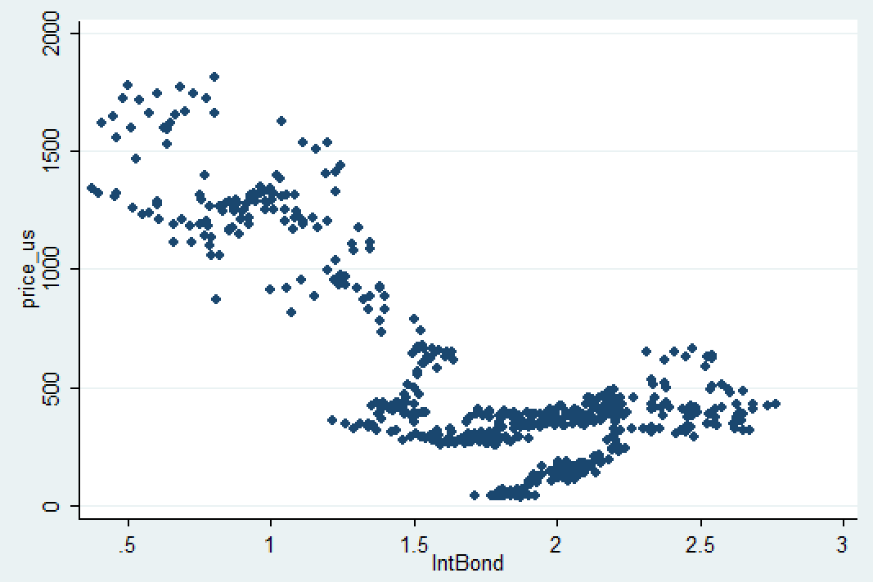

Figure 5

As shown in Figure6, the relationship between the gold price and CPI is similar to the relationship between the gold price and 10 years yield. And the relationship between the gold price and the stock market seems less clear, shown in Figure7. It is probably because the economic stages in different regions in the world are out of sync, resulting in their stock markets running in different phases. For example, after the subprime crisis in the United States, the US stock market began to recover, Europe had long been caught in the European debt crisis, which caused Europeans had a huge demand for gold. However, subsequent analysis discovers that US stock market fluctuation is still a significantly indicative mark for the gold price.

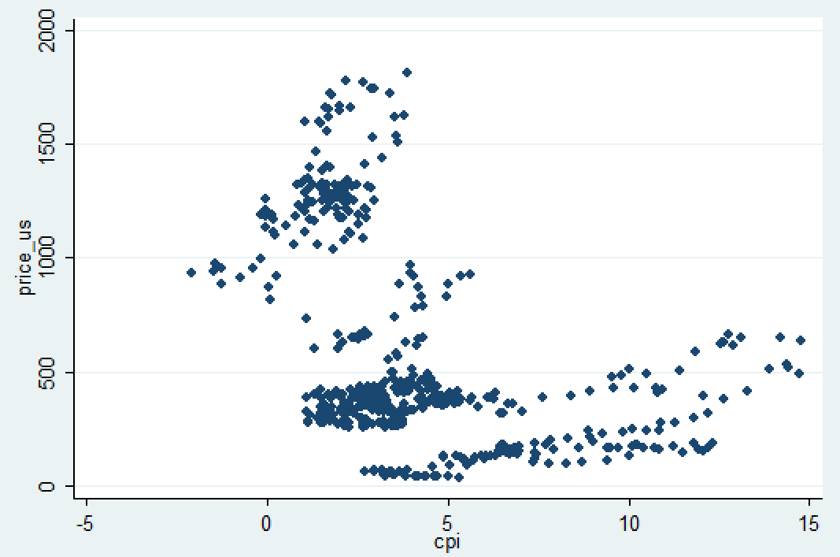

Figure 6

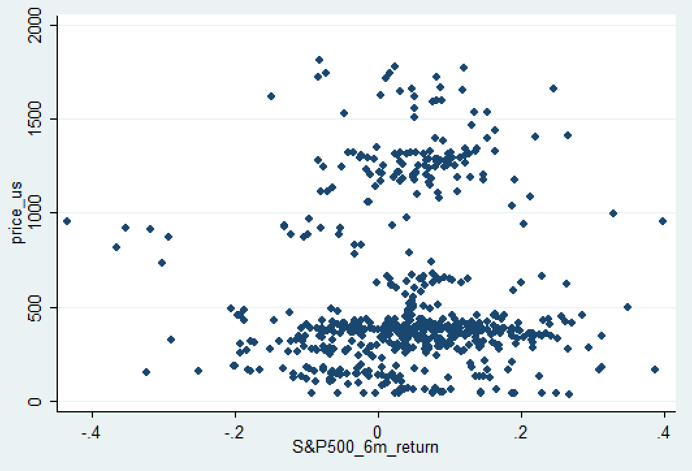

Figure 7

In summary, this data set includes monthly historical data of gold price, cpi, federal fund rate, 10 years yield, US dollar index and six months return of S&P500 index, from December 31, 1970, to May 31, 2019, total 582 observations. The predicted individuals are the gold prices. Obviously, this is a time-series data set.

# Methodology

The OLS model for predicting gold price is supposed to be:

* - - + +

price_us = β0 + β1*lnUSD + β2*lntBond + β3*lnFED + β4*cpi + β5*sp500_6m_return + ε

The hypotheses should be:

* ***lnUSD (independent),*** the monthly US dollar index, which represents the US dollar price. It is expected to have a negative coefficient because the gold price and the US dollar are a negative relationship. Gold is usually denominated in the US dollar. The nominal price of gold will decline when the price of the US dollar increases, holding other conditions constant.
* ***lntBond (independent),*** the monthly average 10 years bond yield, an indicator of the long-term interest rate. It should have a negative coefficient because the gold price and the US dollar are a negative relationship. The 10 years bond yield will go down while the economy is expected to be depressed in the future; the conservative investors will improve their countercyclical asset, including gold. So, gold price goes up as the monthly average 10 years bond yield going down.
* ***lnFED (independent),*** the monthly average federal fund rate, an indicator of the short-term interest rate. Similar to 10 years bond yield, the federal fund rate will fall when the economy is down. The difference is that it is more responsive to current short-term economic changes. Hence, it ought to have a negative coefficient.
* ***CPI (independent),*** Consumer Price Index, measures changes in the price level of a weighted average market basket of consumer goods and services purchased by households, a standard inflation indicator. The monthly US average CPI is used. CPI goes up while high inflation, people would buy more gold to maintain purchasing power, resulting in gold price increases. So, the gold price will change in the same direction as CPI has done.
* ***Sp500_6m_return (independent),*** six months return in S&P500 index, a US stock market indicator. In theory, the relationship between the stock market and gold price should be negative, because stock markets usually fall sharply during economic recessions or crises, and people rush to hedging products, such as gold. On the contrary,
* ***price_us (dependent),*** the gold price, predicted variable. In the case of missing demand and supply variable and geopolitics variable, this model inevitably violates Class Assumption I and III. Nevertheless, this does not prevent the model from effectively explain the gold price.

# Results

The model was estimated in STATA, and the regression output is shown below:

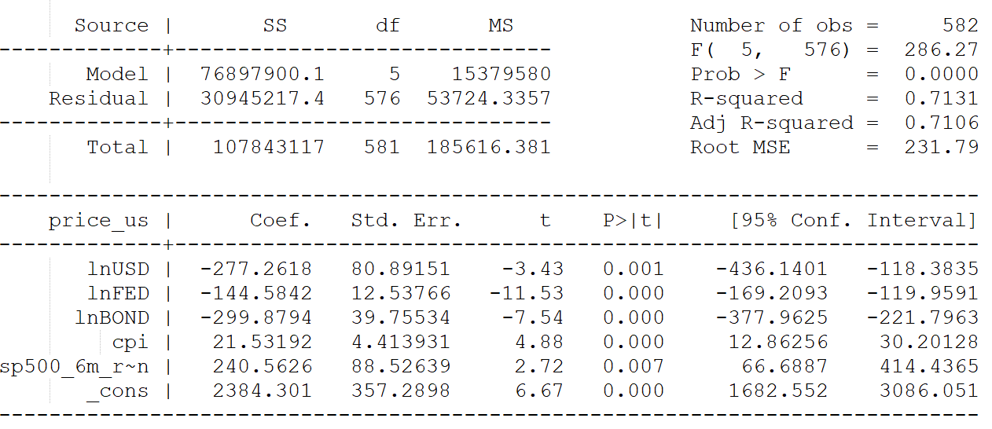

Figure 8

So, the estimate should be:

price_us = 2384.30 – 277.26*lnUSD – 299.88*lnBond – 144.58*FED + 21.53*CPI + 240.56*S&P500_Return

Keeping other variables constant, suppose US dollar index increases 1%, gold price is expected to decrease $277.26; the federal fund rate increases 1%, gold price is expected to decrease $144.58; the 10 years yield increases 1%, gold price is expected to decrease $299.88; CPI increases 1 unit (1 percent), gold price is expected to increase $21.53; the S&P500 index 6 months return increases 1 unit (1% in return), gold price is expected to increase $240.56.

The estimate of the LOG of the US dollar index is negative, is consistent with the previous supposition. The 95% confidence interval from -436.14 to -118.35 suggests that the US dollar index is statistically significant.

The estimate of the LOG of 10 years bond yield is -299.88, with P>| t | of 0.000, which can be believed that 10 years bond yield is a reliable predictor of gold price.

Similarly, the estimate of the LOG of the federal fund rate is -144.58, as the previous assumption. The high absolute t value of -11.53 points out that the federal fund rate is a reliable and important variable for regression of gold price.

In accord with the theory, the estimate of CPI is 21.53. The t value of 4.88 shows that CPI can strongly predict the gold price.

As analyzed above, the estimate of S&P500 six months return is slightly weaker than other parameters for gold price forecast, but its 95% confidence interval of from 66.68 to 414.43 indicates that it is useful and far from zero.

If the mean of independent variables in this sample (lnUSD = 4.6, lnFED = 1, lnBOND = 1.7, cpi =4, sp500_6m_return = 0.04) are substituted into the estimates in this equation, the price_us could be 550.27, which is approximately the mean of dependent variable in this sample. That seems reasonable.

The R2 of 0.71 and adjusted R2 of 0.71 indicates that this OLS model has relatively strong predictive power, that near 70% gold price change can be explained by this model.

# Test

As mentioned above, this data set should be a time series data set. It could be visualized validated, as shown following.

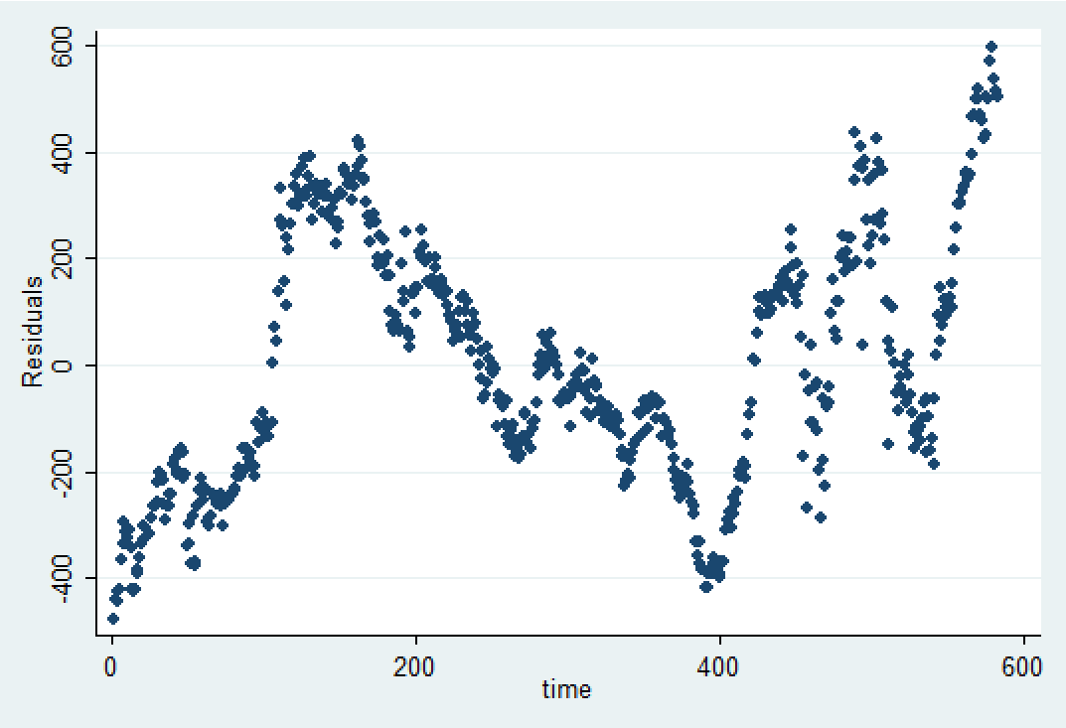

Figure 9

With quantitative analysis, the Durbin-Watson test should be more convincing. The Durbin-Watson test is used to determine if there is a first-order serial correlation in the error of an equation by examining the residuals of a particular estimation of that equation (Studenmund, 2019). The decision rule is: when extreme positive serial correlation occurs, d≈0; while extreme negative serial correlation exists, d≈4; whereas, if no serial correlation exists, d≈2.

According to Figure9, it indicates a positive serial correlation exists. Before the Durbin-Watson test, it is hypothesized that:

H0: $ρ≤$ 0

HA: $ρ$ > 0

Running the Durbin-Watson test in STATA, the result is shown below.

Durbin-Watson d-statistic (6, 582) = .0579949

By checking the critical values of the Durbin-Watson Test Table, on 5% level of significance, with N=582 and K=5, it is shown that dL=1.57 and dU=1.78.

Because the d value of the Durbin-Watson test is lower than dL, the null hypothesis should be rejected. It means that extreme positive serial correlation is detected in this data set.

# Conclusion

This research study the impact of US dollar price, interest rate, inflation and equity market on gold price for the period of December 31, 1970 to May 31, 2019. In order to determine the effect of these variables on gold price, a t-test is appropriate.

Null and Alternative Hypothesis

H0: β1 = 0 H0: β2 = 0 H0: β3 = 0 H0: β4 = 0 H0: β5 = 0

HA: β1 $≠$ 0 HA: β2 $≠$ 0 HA: β3 $≠$ 0 HA: β4 $≠$ 0 HA: β5 $≠$ 0

The regression result, Figure 8, shows that all βs have higher t value, even if S&P500_6m_return of 2.72 is higher than the critical t-value of 2.617 on 1% level of significance, that indicates the null hypothesis should be rejected. So, it concludes that the US dollar index, federal fund rate, 10 years yield, CPI, and S&P500 six months return are statistical significantly correlate with the gold price.

According to the result of model regression, it can be known that the gold prices are a strong negative relationship with the US dollar index, 10 years yield, and federal fund rate, and a positive relationship with the CPI and S&P500 six months return. Among these five factors, the 10 years yield has the most important effect on gold price change.

Further research could focus on: 1. Involving world money supply historical data, gold supply and demand historical data; 2. Using distributed lag model or dynamic model. First, the more money supplied, the more demand to buy gold to maintain purchasing power, and then push up the gold price. Secondly, gold also has supply and demand relationship like other goods. Third, this data set is obvious time-series data, the impact of some factors, for example, inflation and money supply, on gold price would last multiple periods. So, a distributed lag model or dynamic model would be better.

# References

Elfakhani, Said & Baalbaki, Imad & Rizk, Hind. “Gold price determinants: empirical analysis and implications”. 2009

Erdoğdu, Aylin. “The Most Significant Factors Influencing the Price of Gold: An Empirical Analysis of the US Market”. 2017

Gokmenoglu, Korhan & Fazlollahi, Negar.” The Interactions among Gold, Oil, and Stock Market: Evidence from S&P500”. Procedia Economics and Finance. 25. 478-488. 10.1016/S2212-5671(15)00760-1. 2015

Kauffmann, T.D. and Winters, R.A. “The price of gold: a simple model”, Resources Policy, Vol. 15, No. 3, 1989, pp.309–313

Mamcarz, Katarzyna. “Determinants of Gold Price in the Short Term”. 2015

Studenmund, A.H.”Using Econometrics: A Practical Guide”. Edition 7. Pearson Education, 2019, pp. 302